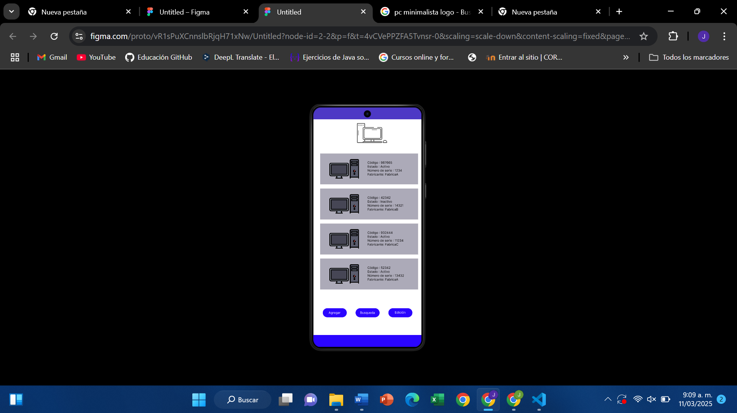

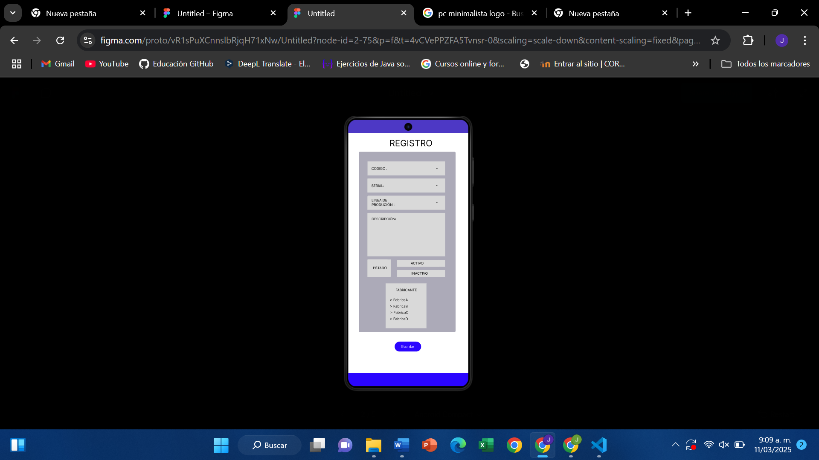

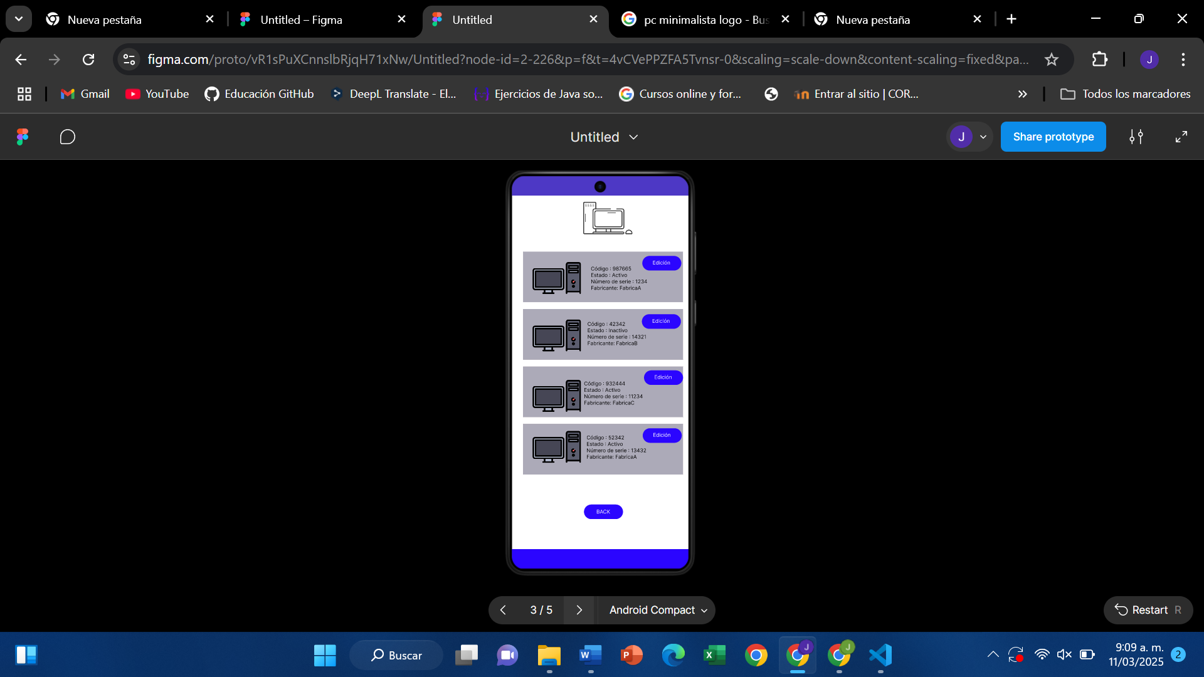

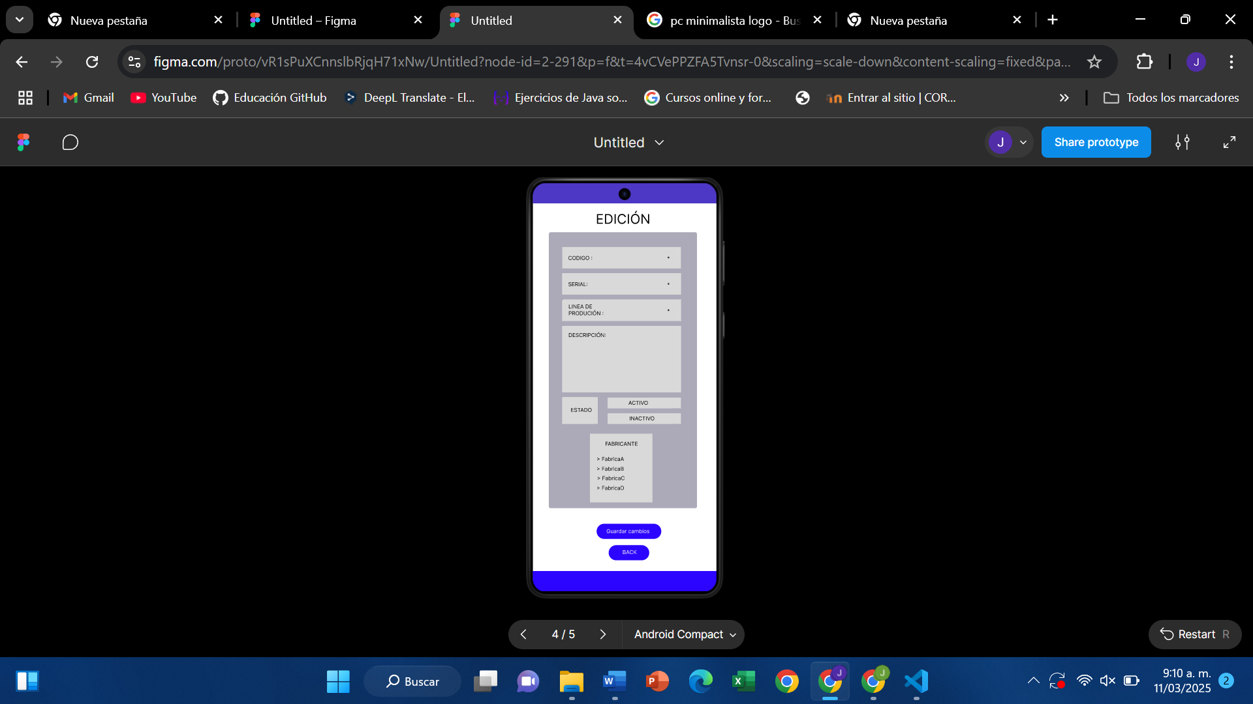

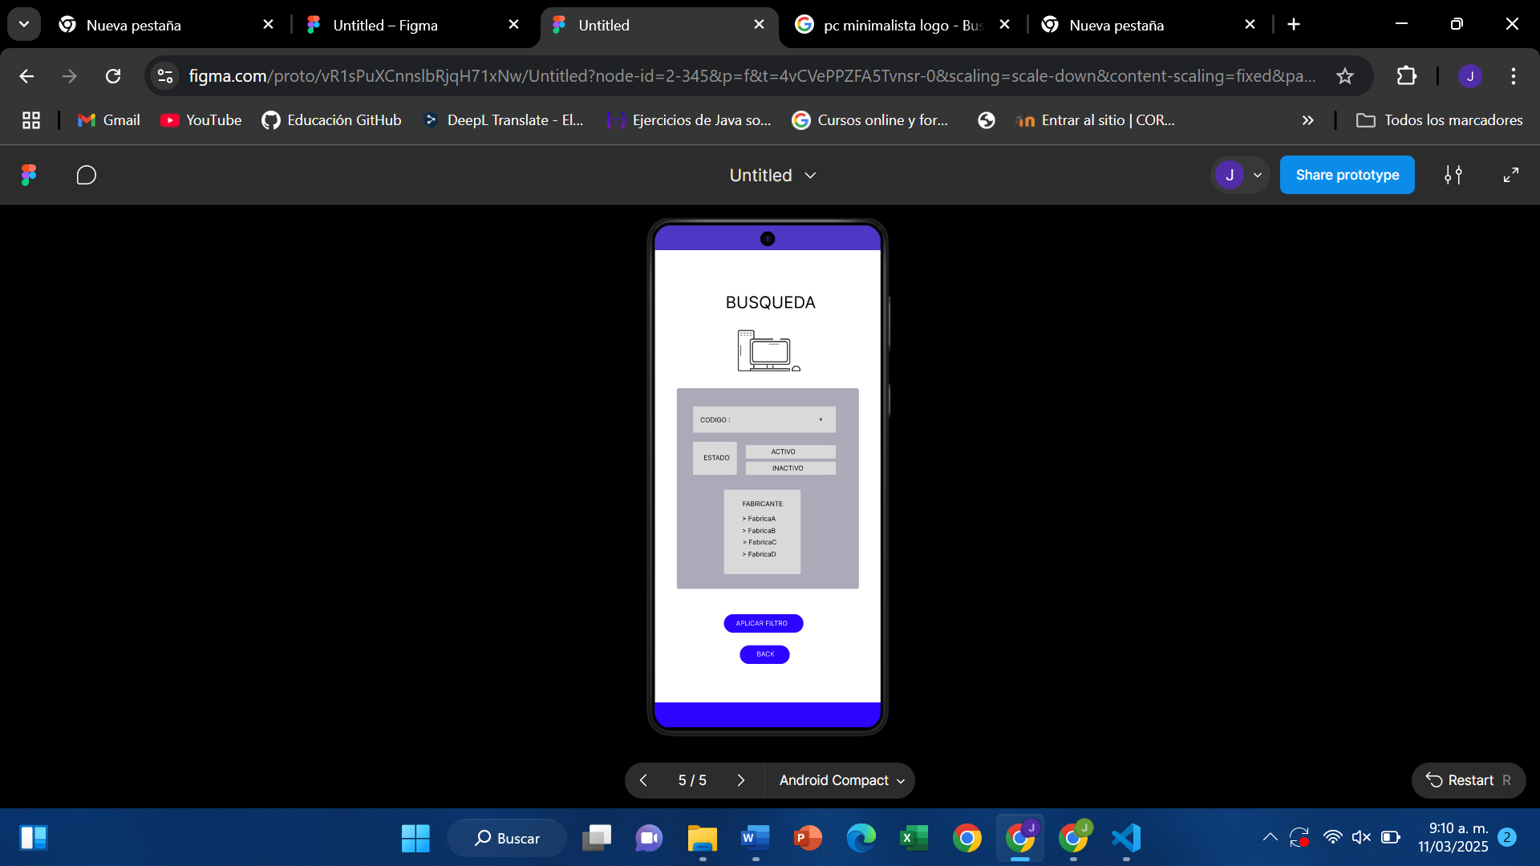

REPOSITORIO: <https://github.com/JuanOliveros2497/programacion-movil-2025-a-g2>

FIGMA: <https://www.figma.com/proto/vR1sPuXCnnslbRjqH71xNw/Untitled?node-id=2-345&p=f&t=CrhSzzOor8An76vy-1&scaling=scale-down&content-scaling=fixed&page-id=0%3A1>